Major Assignment
CS/SCI 3377B

Project Manage the building of a phased occupancy virtual high-rise building through 5 project phases – 30% of total term mark. CS/SCI 3377B Major Assignment General Information:

- Start Date: January 13, 2020 at 11:55 pm
- Due Dates in Owl showing marks in brackets:
  - Phase 1: February 3 at 11:55 pm – Learn the game (6)
  - Phase 2: February 24 at 11:55 pm – Plan the building (8)
  - Phase 3: March 3 at 11:55 pm – Build the Building (8)
  - Phase 4: March 23 at 11:55 pm – Quote Change to Building (3)
  - Phase 5: April 3 at 11:55 pm – Change the Building (5)

General Instructions

You are going to purchase the serious game “Project High Rise” (Version 1.6.3 or later) for ~$21.99 max. Instructions to do so are at the end of this assignment, and also in unit 1 of your lessons. But do not worry about that for the moment, because first you need to understand why. Upon purchasing Project High Rise, you are going to virtually build a high-rise tower with this software. In fact, you are going to try to build the same high rise twice. You are going to build it to my screenshot without a plan once, and then you are going to build it to my specification again, but this time with a plan, following several proper project management processes. Lastly, you will be asked to change your completed building to accommodate an owner desperate to expand his building scope to deal with potential problems in his building holdings.

You will note that in Owl, I have provided you with an Excel workbook that has the necessary formats from which you can generate your work on this assignment. The workbook also contains valuable information for properly planning this high-rise build. This information is on the YELLOW tabs.

Before you proceed to Phase 1 of this assignment, make sure you have read the tutorials located here:

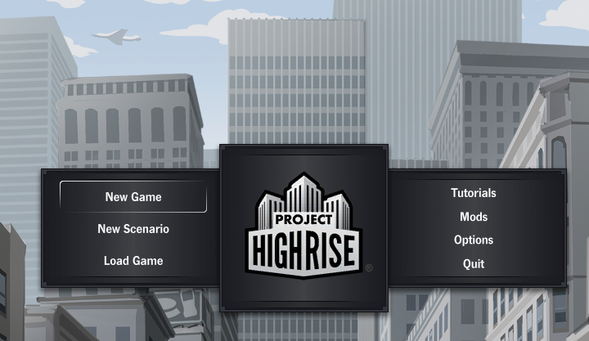

Phase 1 – Learn the game, experiment, and try to work ad hoc

During this phase you will access the Project High Rise for the first time. You will have gone through the tutorials, all 5 of them, provided on the home page of the game and shown above. You did this so you can learn to play the game successfully. Once done with the tutorials, you will now try to create the correct structure shown in section 1.6 of this assignment. You will self-regulate your efforts in this part of the assignment. You will spend no less than 2 hours, and no more than 4 hours working on phase 1 of this assignment. This is important for appreciating the intended learning outcome.

The first time you try to build the building in section 1.6, you will keep records including:

- a diary of what went right, and wrong – Lessons Learned (2%)
- a screen shot of your building when completed, or as complete as you get it in 4 hours max allotted for phase 1. (2%)
- a list and description of enterprise environmental factors (see our week 1 lecture notes) that you discover. You have been given room to write in 40, but you will be lucky to find 6 to 10 good ones and maybe a few others. You should find at least 5 that you can speak to. (Showing yourself around in “Pause” mode will help you gather facts) (2%)
Open, complete, and submit your records from 1-3 above in the Excel workbook, found in Owl, supporting this phase of the assignment. You need to complete all the ORANGE tabs for this Phase 1 submission (except the last column in Lessons Learned).

I will mark these items. You will hand them in February 3 in Owl (6%)

Phase 2 – Create a plan to build the building

The second time you try to build the structure in section 1.6, you are going to create a project management plan first to see if this helps you. You will create:

- a stakeholder plan (2%)
- a risk plan (2%)
- a WBS, (partial example provided, student must completely redo it) (2%)
- a baseline daily Finance plan (2%)

I will mark these items. You will hand these in February 24th in Owl. (8%)

Submit your plan in the format provided on the support Excel workbook for this assignment. You need to complete all the GREEN tabs. Expand column widths and add rows if/where necessary.

Phase 3 – Build the Building

The second time you build the high rise, you will have results consisting of evidence showing:

- Additional diary entries w.r.t. your efforts in applying the plan. (0.5%)
9. A screen shot of your building as complete as you get it (0.5%)
10. A minimum deliverable of 7 apartments with happy clients (1%)
11. A minimum deliverable of 19 offices with satisfied clients (1%)
12. Exactly 4 stores & minimum 4 restaurants that are viably operating (1%)
13. A deliverable of a daily population of 70+ using the building (1%)
14. A deliverable of a building that is returning revenue of $500/day min. (1%)
15. A 1-page contrast of results of working with and without a PM plan (2%)

Item 8 should be added to your earlier ORANGE tab “diary of lessons learned”. Items 9 through 14 should consist of new screen shot(s) on the earlier ORANGE tab “screen shots”. CLEARLY DISTINGUISH YOUR PHASE 3 WORK FROM EARLIER PHASE 1 WORK.
Item 15 should be written up in Word, then screen captured and dropped into the BLUE tab “Contrast of Results”. Arial 11-point font, double spaced. 400 words max.; What was different when you had a plan?

I will mark these items. You will hand these in March 3rd in Owl. (8%)

Phase 4 – Quote to Change the Building

You have a fully functioning building after phase 3. But, the owners have decided to make modifications to the building to cope with the new realities of their business. Monitor Owl announcements and emails from the course instructor. You will be shown an update of the required plan on Mar 2nd, 2021. Over the next week of your Major Assignment, you will quote required changes consisting of evidence:

- A cost (PV) & price estimate for the $ you will spend on the change. (1%)
- An updated daily Finance plan that includes the change (1%)
- Diary entries of expected stakeholder reactions w.r.t. the change (0.5%)
- Document the management of this change (0.5%)

When we built the WBS in phase 2, we only considered materials, labor, and expenses. But in phase 4, we will also consider “carrying costs” which we will explain to you in the November 4th or 11th Major Project lecture/tutorials held in Zoom.

You will enter item 1 in the GREY tab “Change Estimate PV”. You will enter item 2 in the GREY tab “Updated Finance Plan”. You will enter item 3 in the ORANGE tab “Lessons Learned”. You will complete item 4 on the YELLOW tab “change management”.

I will mark these items. You will hand these in March 23rd in Owl. (3%)

Phase 5 – Change the Building

You have a fully functioning building after phase 3. But amidst the changes to their business in this new economy, the owners have decided to make modifications to the building to cope with possible occupancy problems in their high rise portfolio. You were shown an update of the required plan on or around March 2nd, 2020, and you quoted the proposed changed March 23rd, 2020. Over the last week of your Major Assignment, you will now show final results consisting of evidence:

1. A building screen shot as complete as you get it including change (1%)
2. A minimum deliverable of xx new apartments with happy clients (1%)
3. A minimum deliverable of xx new offices with satisfied clients (1%)
4. (PV) phase 4, actual cost (AC) & earned value (EV) from phase 5. (1%)
5. A final few diary updates in your lessons learned (1%)

Items 1 through 3 should consist of new screen shot(s) on the earlier ORANGE tab “screen shots”. CLEARLY DISTINGUISH YOUR PHASE 5 WORK FROM EARLIER PHASES 1 & 3 WORK. You will enter item 4 in the RED tab “PV & AC”. You will enter item 5 in the ORANGE tab “Lessons Learned”.

I will mark these items. You will hand these in April 3rd, 2020 in Owl. (5%)

General Specifications

  - The Product – The high rise you are building is to look as much as possible like the one I have attached as an example in section 1.6. You will no doubt have subtle differences with mine, because each student PM in the class will have their own set of random events that impacts their construction activities. And further, you have the authority via your charter to show some leadership in this regard as well. Generally, the following elements are required:
    - 19 offices
    - 7 apartments
    - 4 restaurants and 4 stores
    - 8 stories above street, 2 stories below – exact

  - Starting the game – When you start Project High Rise, you need to do the following things:

    - Start Project High Rise. Click on New Game:

Do not adjust any set points in options, and do not start from “new scenario” or “load game”.

    - Click on the Start button:

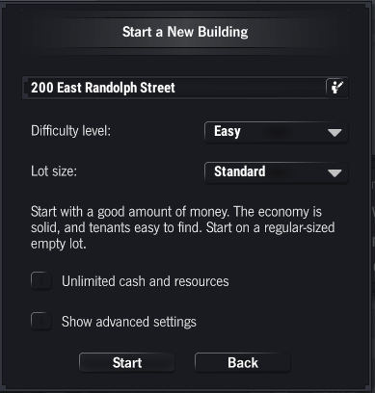

    - And now we are into the point where your skills will take over:

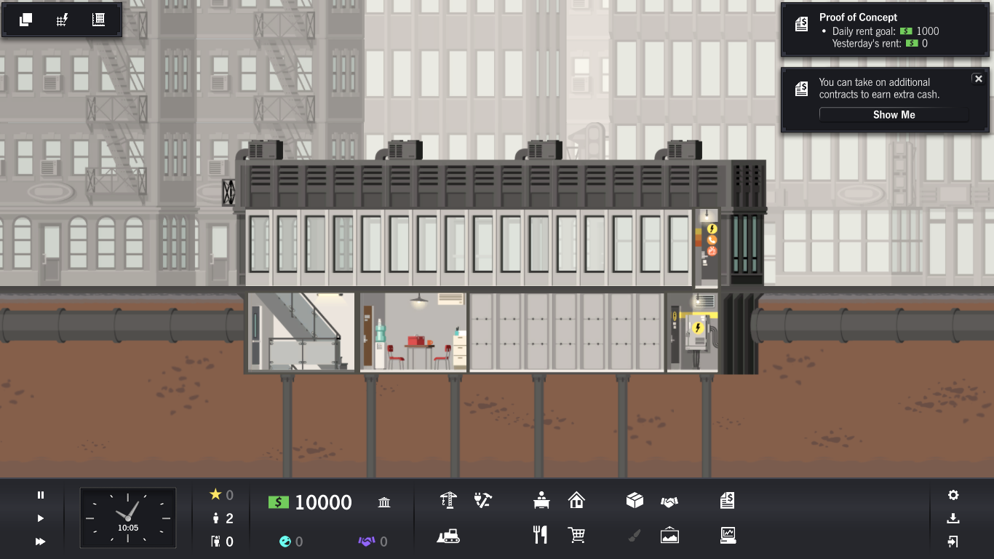
  - The business side of things - You will build a building that has room for apartments, offices, restaurants, and stores. The occupants of these areas will move in after you build up their area of the high rise. The rent they pay will offset the $10,000 original investment in this project. You have two other options for raising additional funds if necessary, at any point.

    - Contracts – Student PMs will note that the “Proof of concept” contract was already signed before you received your charter. You can manage that for extra money. And there are others for your consideration as well.
    - Loans – A variety of loans are available. The PM will note his/her financial circumstances may not allow access to the loan. A certain amount of prestige is typically required for better loan options.

You may have to raise funds to keep your daily cash flow positive. Otherwise you will not be able to afford to keep building.

  - The technology side of things - Construction must proceed in a logical manner. Infrastructure services primarily originate in the below grade areas and rise through the building. Your tenants require some or all of these infrastructure services to exist, but in varying quantities.

    - Your workers will need to access areas if they are to do any work there. Keep that in mind.
    - Construction will not flow smoothly. It never does when clients are on site. Watch for risks being realized.
    - Note that all your hard work can be undone if tenants move out because your stakeholder management is inadequate.
    - When it comes to services, note that each service type has a piece of infrastructure you must install as a starting point in the building: water meters, TV transceivers, transformers, etc.
    - Once you have your service starting points installed, you may then install the rest of the service via closets, risers, and finally horizontal distribution lines.
    - Fluid based services share plumbing closets. Electricity based services share wiring closets.

  - The Human side of things – Once you move people into an area, you want to continue building. But these new stakeholders have issues. They do not like the noise you make, the smells on site, the rent they pay, and the general overall state of the building at times. And many other things. You must deal with that in a manner that keeps them satisfied enough, without breaking your finances or altering your plans too much. So have a good plan for keeping them happy and your job will be easier.

    - Certain people need certain creature comforts.
    - If you ignore concerns, you will get hit in the wallet every time.
    - Sometimes you do things you hope will change the mood, but you see no immediate change. Drill down deeper with that individual to see if they are feeling a bit better. If so, you can move on to the next issue.
    - There are smart places to put things, and little tricks to keep people happy. It may be wise to remember the old real estate adage: Real estate is all about 3 things: “Location, Location, and Location”.
    - There is often more than one way to keep your stakeholders happy. Choose the most financially viable way.

  - Construction of the Product (one example) – See the screen shots below. They reflect the progress that was made in one solution to AN EARLIER VERSION of this assignment that had a different building design from what you are making. These screen shots provide you with a bit of illustrated guidance for how your similar building might progress as you build it. At the very end of this sequence of screen shots, we have dropped in a screen shot of EXACTLY WHAT YOU WILL BUILD (depending on your last name)

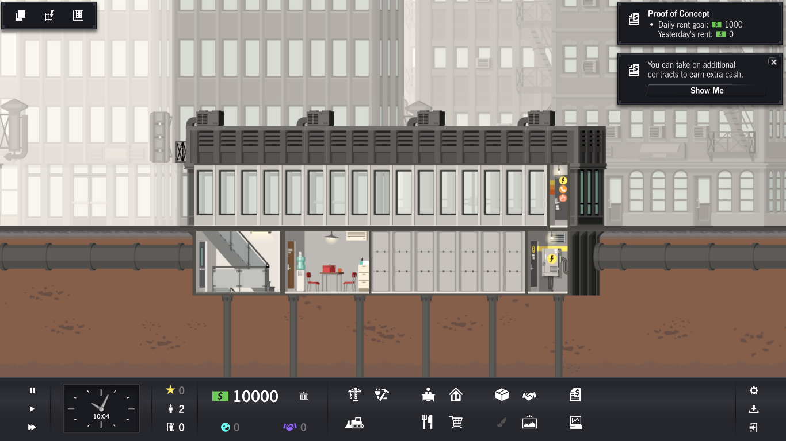
Example of a Building in Progress. NOT your building
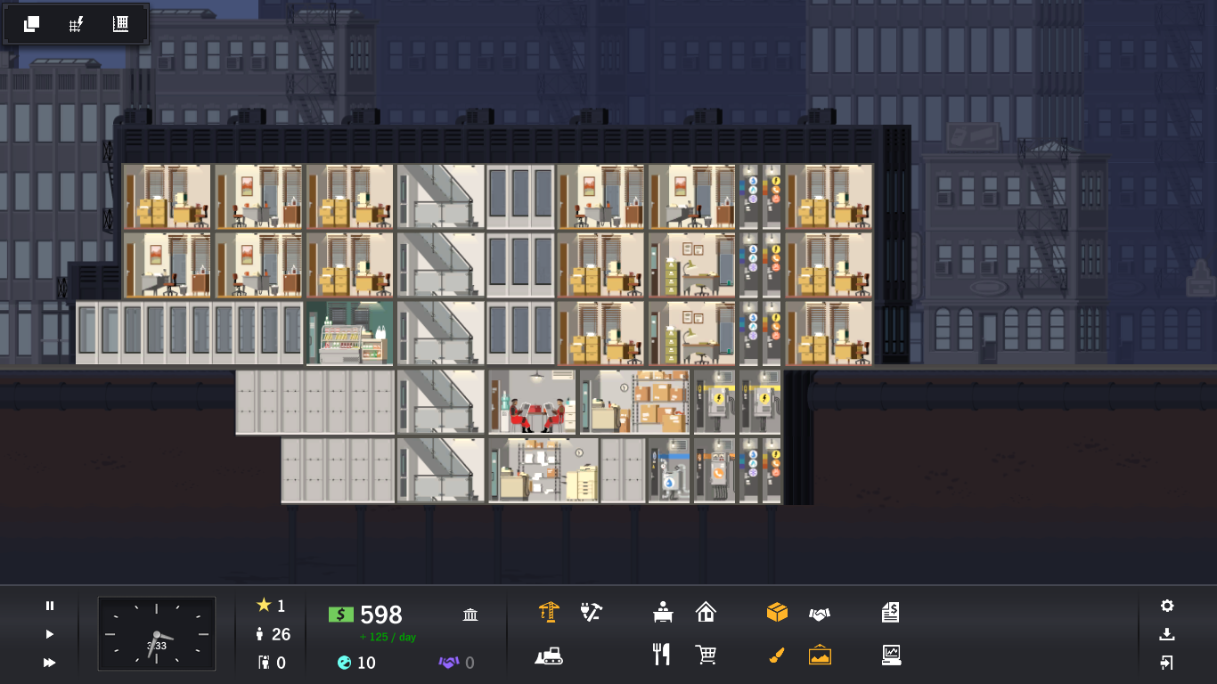
Example of a Building in Progress. NOT your building
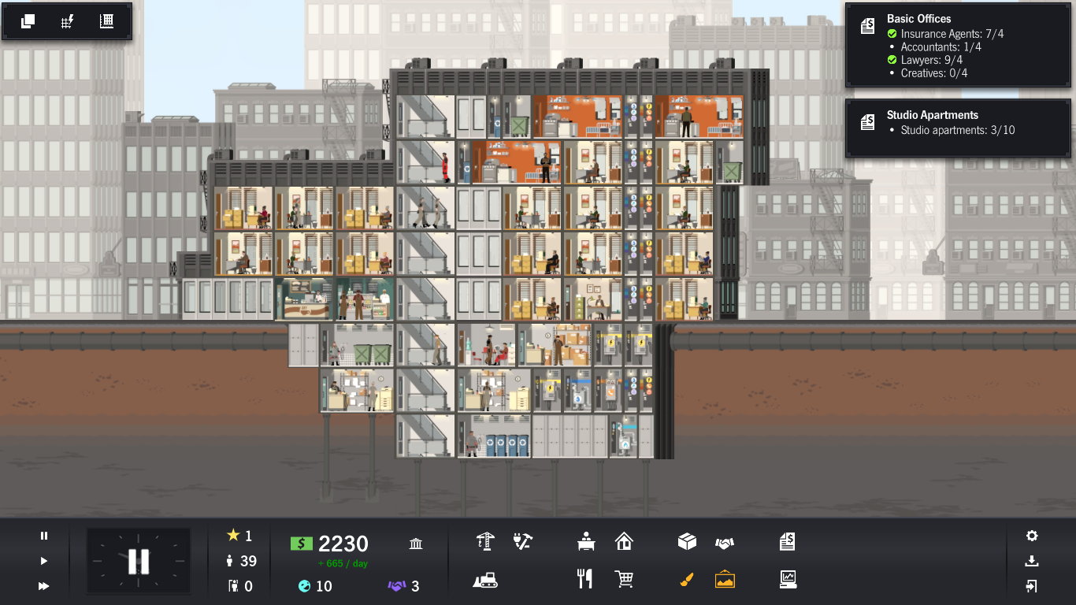
Example of a Building in Progress. NOT your building
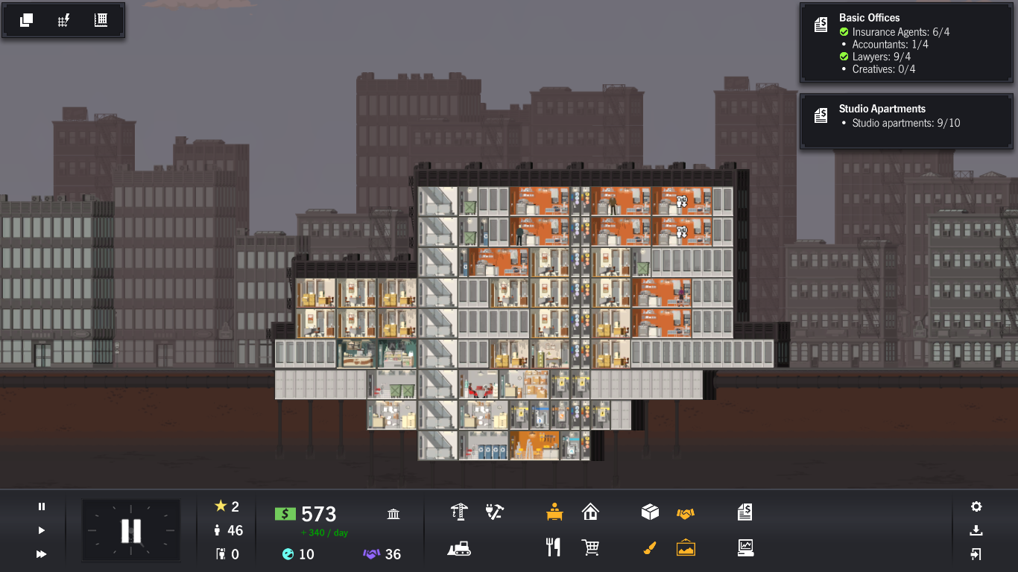
Example of a Building in Progress. NOT your building

And lastly……. Now a screen shot of what YOUR finished building will look like after you complete a similar construction process. A PowerPoint version will be provided with this assignment so you can more easily see the details. Note that it satisfies the height requirements both above ground, and below ground. It is turning a profit of +$500/day. And, it has the requisite number of restaurants, stores, offices, and apartments. Also note we have TWO versions this semester. Build the one that corresponds to your last name:

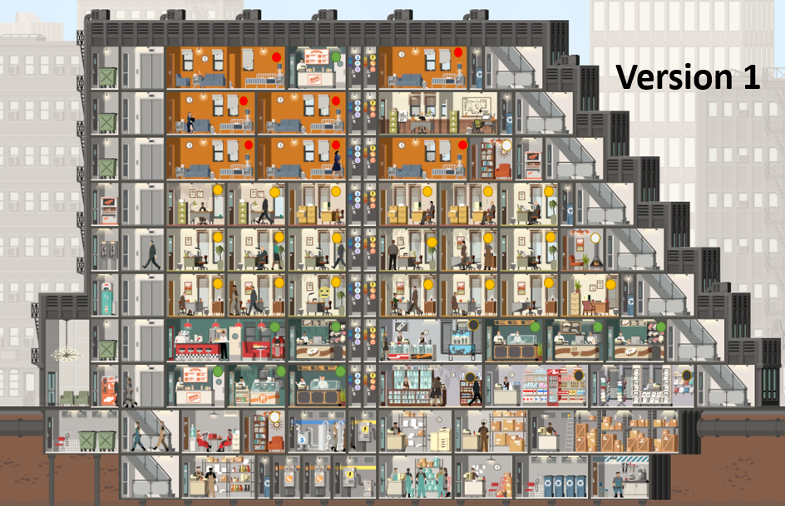
This is your building if your last name is between A to M inclusive

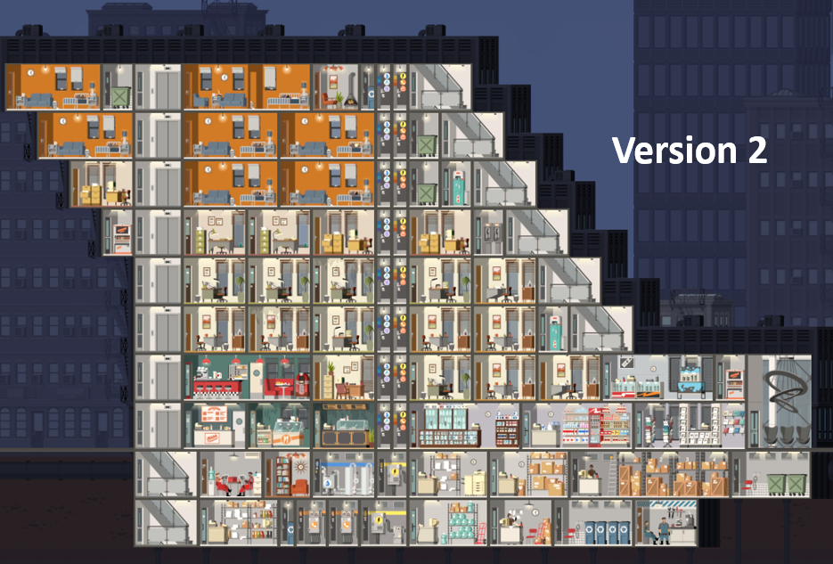
This is your building if your last name is between N to Z inclusive

1.7 Purchasing your copy of Project High Rise

PLEASE SEE THE DIRECTIONS YOU HAVE BEEN GIVEN IN UNIT 1 IN ORDER TO GET PROJECT HIGH RISE ON YOUR MACHINE. IT COSTS A FEW DOLLARS, SO DO NOT BE SURPRISED.

IF YOU ARE FOLLOWING ALONG IN THE COURSE AT THE RECOMMENDED PACE YOU SHOULD ALREADY HAVE BOUGHT THE GAME.

GOOD LUCK WITH THE MAJOR ASSIGNMENT! HAVE FUN….BUT CHALLENGE YOURSELF.

Revision Control of this document:
Rev00 release: December 20, 2020 start of semester site build release to CTL
Rev01 release: December 30, 2020 website construction. Dates adjusted.

